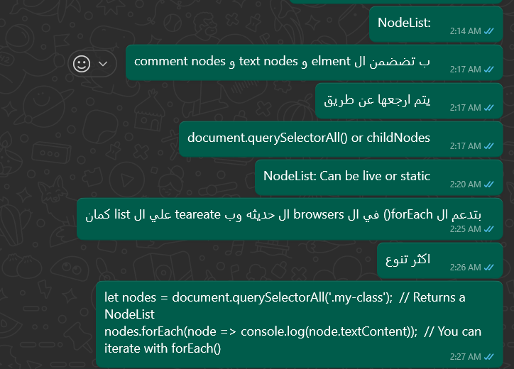

|  |  |  |  |  |  |  |  |
| --- | --- | --- | --- | --- | --- | --- | --- |
| Decorative | | | | | search  HTML Collection vs Node list  Append vs Appen child  عباره عن مجموعتين من  Dom  بس ليهم خصائص مختلفه | | |
| Experience | | | | | | | |
| HTMLCollec on |  | |  | عباره عن مجموعه عناصر من ال  Html  يتم ارجعها عن طريق  document.getElementsByClassName() or document.getElementsByTagName()  Is live  لا تعدعم ال  direct iteration زي  for each  ٧ولكن ب تستخد  for loop  عادي  Limited methods  let elements = document.getElementsByClassName('my-class'); // Returns an HTMLCollection  console.log(elements.length); | | | |
|  |  |  |
| NodeList |  | |  |
|  |  |  |
|  | | | | | | | |
|  | | | | | | | |
| NodeList |  | |  |
|  |  |  |
|  |  |  |  |
|  |  | |  |
|  |  |  |
|  | | | | | | | |
|  | | | | | |  |  |

